
Violet Way Academy Curriculum

Aim | At Violet Way Academy we want all of our pupils to ‘Reach for the Stars’. This means setting aspirational goals, persevering in the face of challenge and striving for excellence in all that they do. Our nurturing and supportive staff team work together to ensure that each and every child is encouraged, supported and inspired to broaden their ambitions.
Trust Vision | Inspiring all to excellence
Trust Values | We care   |  |  |  | We leave no-one behind   |  |  |  | We celebrate individuality   |  |  |  | We are brave  
Star Learner
Big ideas | V | I |  | O |  | L |  | E |  | T |  | W |  |  | A | Y
Big ideas | Vocabulary & Communication   | Inquisitive   |  | Outdoor learning  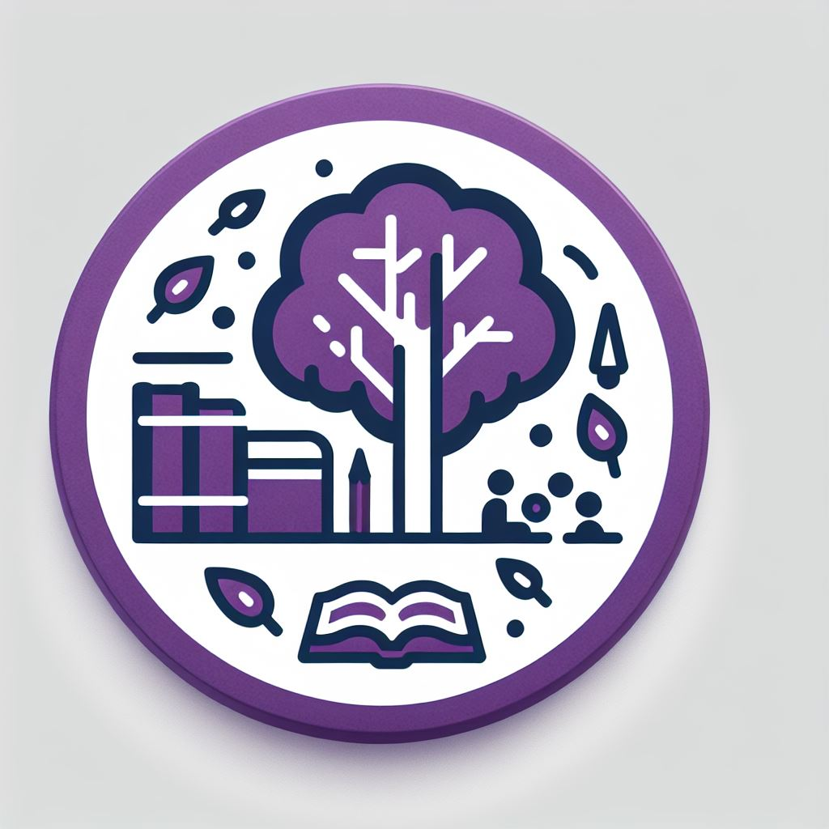 |  | Learning critically   |  | Expressive   |  | Teamwork   |  | Wellbeing   |  |  | Adventure   | You (Independence)  

Curriculum Intent
Our school vision and values, curriculum vision and key curriculum drivers have informed the content we expect children to learn at Violet Way Academy.
We use the EYFS Framework and the National Curriculum as the basis for our Violet Way Academy Curriculum. Each subject’s curriculum is planned and sequenced so that new knowledge and skills build on what has been taught before, and towards agreed end-points, as identified on the academy’s Progression Grids for each subject.
We want to raise aspirations, build teamplayers and resilience as well as promoting creativity and curiosity.
Our curriculum builds on prior knowledge and prepares pupils for what comes next.

Subject Specific Sequencing and Key Concepts- Each subject has been planned to ensure that knowledge and skills are sequenced from Early Years to year 2 and further due to our collaboration with Edge Hill. Key Concepts are subject specific ‘Golden Threads’ that children will learn about return to and revisit as they progress through our school. Providing opportunities to link new learning to prior knowledge- building a rich and deep knowledge of these Golden threads.

Big Ideas: These are overarching Violet Way concepts that pupils can use and apply through different curriculum subjects.

V | I | O | L | E | T | W | A | Y
Vocabulary and communication | Inquisitive | Outdoor | Learning critically | Expressive | Teamwork | Wellbeing | Adventure | You (Independence)

